MSI Rover

Subject: Physics, Mechanical Engineering, Electronics, Mechanical advantage, motion, electricity, friction, torque  Related Subjects: Automotive, and Electrical, Engineering | Grade Level(s):2,3,4,6,8  Length of Lesson: | Type: Inquiry / Design / Project  Keywords:Series circuit, gearing, axle, chassis, alignment

Lesson Overview

ROVs like the Mar’s rover have helped scientists gather soil samples from outer space and harsh environments. They’ve also been used by law enforcement and the military. These ROVs are maneuverable cars that are connected by a tether, a group of cables that carry electrical signals back and forth between the operator and the vehicle.



Lesson Focus
Student will create a chassis, wheels, gearing system and an electrical circuit in a car that can operate semi-autonomously and as an ROV.
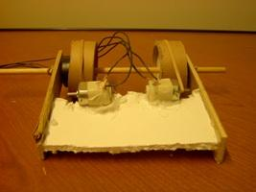

Lesson Objective(s) | - Students build rear suspension (wheels and axles) from tubes, foam core and wood dowels.  - Students build chassis from wood base shoe and foam core.  - Students create series circuit with motor, batter holder and switch  - Students assemble MSI rover.  - Students demonstrate mechanical advantage by connecting gears (motor stem to tube wheel) via rubber band.  - Students will collect soil samples using MSI rover

Lesson Timing

5 minutes | Introduce the Lesson
30 minutes | ...

Materials | - –Foam core  - –Wood dowels  - –Wood base shoe  - –Sturdy tube (5cm diameter shown)  - –1.5V motors  - –Battery holder  - –2 position switch  - –Wire  - –Solder core resin  - –Soldering Iron  - –Glue gun and glue sticks  - –Film canister  - –Wire stripper  - –Rubber bands  - –Electrical tape  - –Marble  - –Soil collectors (tubes 1cm diameter, 2cm length)
Instructor Prep | - Step 1
Related Resources | - List related lessons/ppts etc available from USC or outside, trusted orgs

Lesson Plan

Introduction
The rear suspension of the rover comprises a wood dowel axle and two tubes cans. Each dowel is inserted lengthwise through a can with a foam core wheel base attached to in the center of each tube. 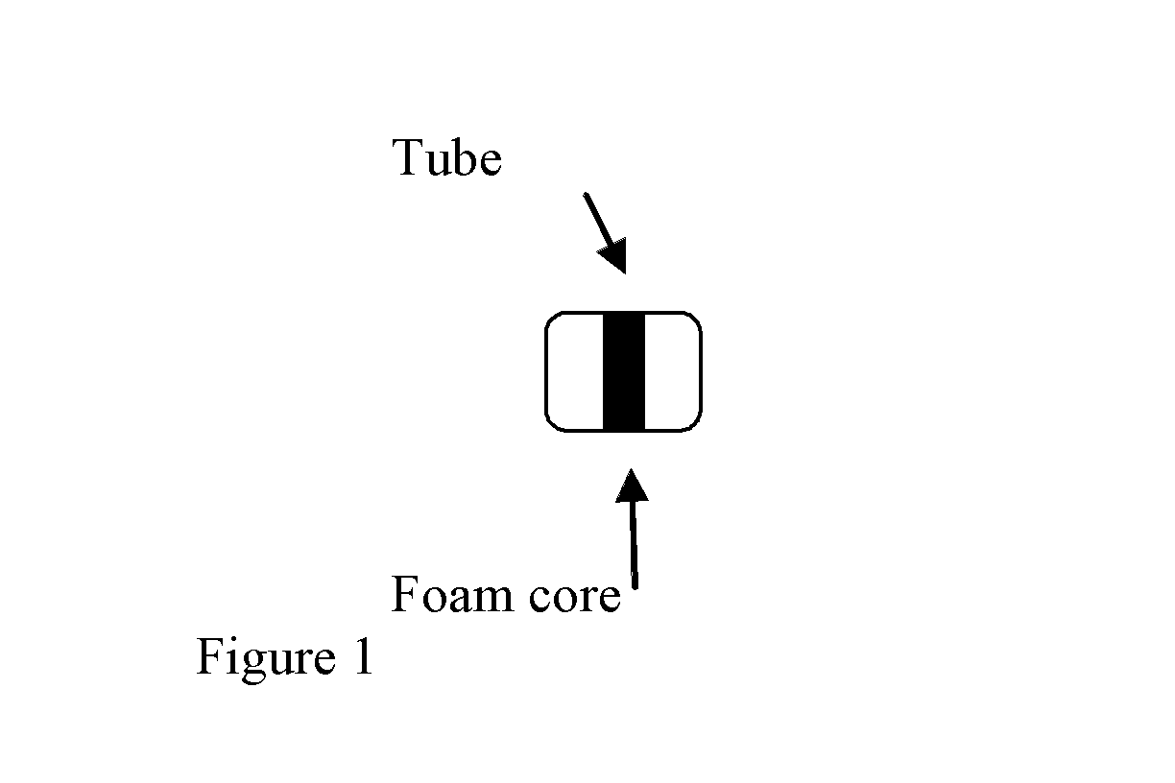

The chassis of the rover has to be:

Sufficiently thick to carry the weight of the motor, switch, and battery holder.
Sufficiently sturdy to withstand the torque and pull of the motor, belt and rear wheels.

Figure 2 is the shape of the rover chassis.

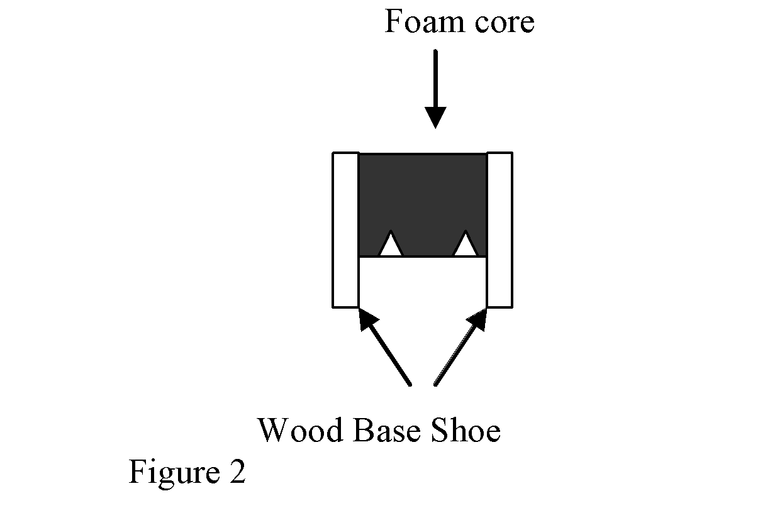

A series circuit is formed when an electrical source (battery) is connected to an object (motor, light…) which is connected to a switch which is connected back to the battery.
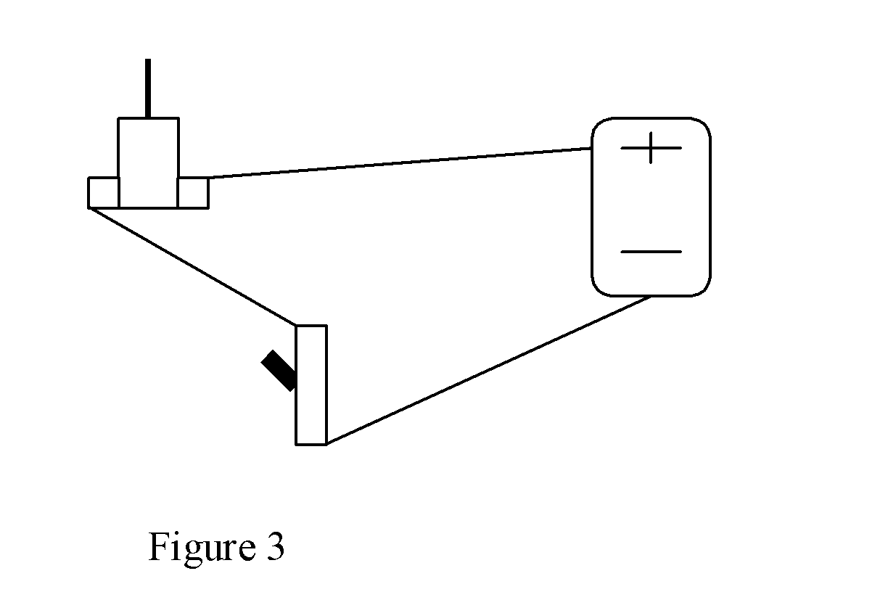
When the switch is off, the circuit is open and electricity can’t flow. When the switch is on, the circuit is closed and electricity can flow.

The rover must be assembled so that the wheels are placed at back end of the chassis and the motor stem is parallel to the rear wheel. A rubber band goes around the motor stem and rear wheel as a belt. This is the gearing system. The mechanical advantage is the ratio of the diameter of the can to the diameter of the motor stem. The greater this number, the stronger the turning force.

The variables to this design are in chassis length and width, suspension, and placement of the motor.

Procedure

Safety Procedures
- Caution should be exercised with cutting utensils (scissors, X-acto blade).
- Students should be careful with hot surfaces (glue gun, soldering iron).
- Proper safety procedures and equipment should be used for drill, drill press and belt sander.

Instructions

–Cut two pieces of tube 3cm in length
–Trace and cut two circles of foam core the same size as the tubes.
–Cut two film canisters to the height of 2cm
–Glue the new top of each film canister to a circle
–Drill hole in canister through foam circle
–Insert circle into each of the tubes
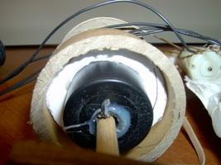 (See also figure 1).
–Cut a dowel about 20cm long.
–Insert dowel through holes of both tubes (this is the wheel- axle)
–Cut a 15cm square foam core
–Cut two “V”s in one end (see figure 2)
–Cut 2 pieces of wood base shoe. The wood must be long enough for both tubes to spin freely when connected to the chassis.
–Drill a hole in each end of one piece of wood.
–Measure and mark the holes from the first piece of wood to the second to make sure the holes line up.
– Drill a hole in each end of the other piece of wood where marked.
–Glue the foam core to the pieces of wood like the model in figure 2.
–Glue marble to bottom of the front of the rover
–Place tape over openings on motor
–Maintaining balance of rover, glue motor to chassis with the stem parallel to wheel axis and over the “V” (figure 4) Stem facing right makes car move one way, stem facing left makes car move the other way. Student must test before gluing to determine which way to glue motor so that both motors move the same direction when switches are flipped.
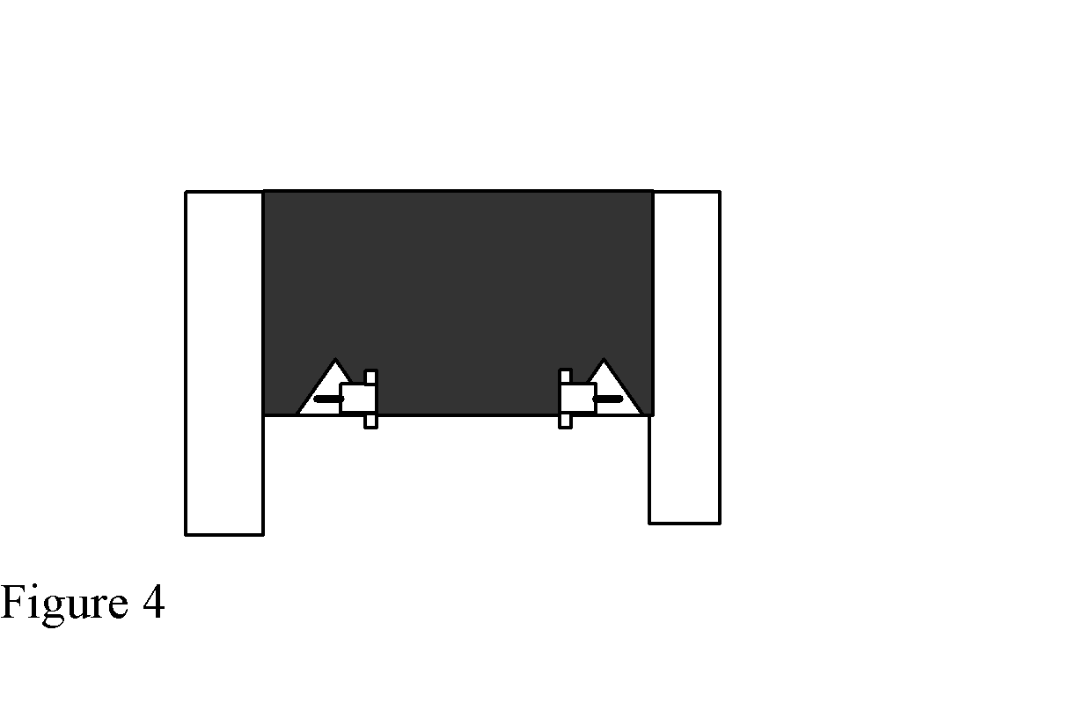
Cut and strip wires 4- 5inch wires and 2-3inch wires
–Insert one 5inch wire to one clip on motor
–Insert another 5inch wire in other clip on motor
–Tape or Solder wires to motors
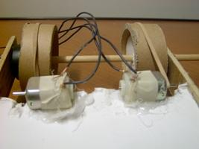
–Connect one of the free ends of motor wire to the back of an alligator clip
– Connect the other the free ends of motor wire to the back of another alligator clip.
–Tape or Solder red wire from battery holder to center hole in switch
–Tape or Solder a 3 inch wire to either outside hole on switch
–Repeat for second motor and second switch
–Glue switches to side
–Glue battery holders to whichever part of chassis that maintains balance.
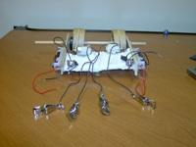
–Check for stability and balance.
–Place rubber band from tubes around stem of motors (student may have to place holder on end of stem to keep rubber band from sliding off).
–Connect alligator clips to wires and flip the switches
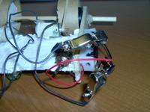
–Change the connections of alligator wires and notice the difference. The boat either moves forward, backward, turns right or turns left depending on how you connect it.

Wrap-up
- Students should be able to make necessary adjustments to make rover travel in a straight line
- Students attach rover to teacher controller and gather samples

Lesson Background for Teachers

Suggested Real-World STEM Connections
- List possible related Role Models in STEM (with details and links to more reading). Give suggestions for examples of scientists/engineers who are from underrepresented groups in STEM in related careers.
- List related real-world engineering problems and examples

Lesson Variations and Options
Include descriptions of alternative methods or ways to present things.

Explanation
Describe the background concepts and explanations behind the lesson. This can be more in depth than a teacher/instructor would actually share with students.

Key Concepts and Vocabulary
- Word 1: Grade Appropriate Definition
- Word 2: Grade Appropriate Definition

Safety Notes
- Safety instruction

